05/10/13

CAP 204

Advanced Modeling
Plan of Instruction

Effective Date: Spring 2013 Version Number: 2013-1

COURSE DESCRIPTION:

This course deepens students’ knowledge of CGI object modeling. Emphasis is placed on study of human anatomy, use of good reference material and realistic proportions. Topics also include animal anatomy and industrial objects. Upon completion, students should be able to recreate complex object of various anatomy and designs efficiently.

CREDIT HOURS

Theory Credit Hours 1 hour
Lab Credit Hours 1 hour
Total Credit Hours 2 hours

NOTE: Theory credit hours are a 1:1 contact to credit ratio. Colleges may schedule lab hours as 3:1 and/or 2:1 contact to credit ratio. Clinical hours are 3:1 contact to credit ratio. (Ref Board Policy 705.01)

PREREQUISITE COURSES

CAP 121

CO-REQUISITE COURSES

As determined by college.

PROFESSIONAL COMPETENCIES

- Describe the theoretical and technical steps to achieve a flawless CGI model.
- Value the importance of a good anatomical understanding.
- Use the knowledge of anatomy to create accurate CGI characters.

INSTRUCTIONAL GOALS

- Cognitive – Comprehend principles and concepts related to character and object modeling.

- Psychomotor – Apply principles of character and object modeling.

- Affective – Value the importance of observation and study of anatomy to create high quality CGI models.

STUDENT OBJECTIVES

Condition Statement: Unless otherwise indicated, evaluation of student’s attainment of objectives is based on knowledge gained from this course. Specifications may be in the form of, but not limited to, cognitive skills diagnostic instruments, manufacturer’s specifications, technical orders, regulations, national and state codes, certification agencies, locally developed lab/clinical assignments, or any combination of specifications.

STUDENT LEARNING OUTCOMES

MODULE A – ADVANCED POLYGONAL TOOLS AND MODELING EFFICIENCY
MODULE DESCRIPTION – This module instructs students on various advanced tools required to create optimal CGI models. Topics include polygon topology, polygonal edge flow, loops, polygonal modeling tools, surface subdivision and polygon reduction tools.
PROFESSIONAL COMPETENCIES | PERFORMANCE OBJECTIVES | KSA
A1.0 Describe the theoretical and technical steps to achieve a flawless CGI model. | A1.1 Use CGI skills to create various characters and objects. | 3
A2.0 Value the importance of a good anatomical understanding. | A2.1 This competency is developed throughout the course. | A
LEARNING OBJECTIVES |  | KSA
A1.1.1 Describe various polygon topology and their uses.  A1.1.2 Explain the edge flow theory and its limitations.  A1.1.3 Explain loop selection and manipulation tools.  A1.1.4 Explain the polygon duplication tool and the replication mode.  A1.1.5 Describe hull creation with curve net tool.  A1.1.6 Explain proportional modeling mode.  A1.1.7 Explain the symmetry mode.  A1.1.8 Identify component linking tools.  A1.1.9 Explain local and global polygonal subdivision.  A1.1.10 Explain surface subdivision mode.  A1.1.11 Describe polygon reduction tools. |  | 3  4  4  3  2  3  3  2  3  3  2
MODULE A OUTLINE:
- Polygon topology
- Triangle
- Quadrangle
- Polyangle
- Tweak component tool
- Polygonal edge flow
- Loops
- Polygonal modeling tools
- Polygon duplication
- Curve net
- Proportional modeling tool
- Symmetrize polygons
- Insets
- Split edges
- Bridge
- Polygon subdivision
  - Local refinement
  - Dicing and slicing
- Surface subdivision
- Polygon reduction tools

MODULE B – UNDERSTANDING ANATOMY
MODULE DESCRIPTION – This module instructs students on using the knowledge of anatomy to create accurate CGI characters. Topics include facial anatomy, general human anatomy and proportions, symmetry tools, animal anatomy, and composite anatomy.
PROFESSIONAL COMPETENCIES | PERFORMANCE OBJECTIVES | KSA
B1.0 Use the knowledge of anatomy to create accurate CGI characters. | B1.1 Use CGI skills to create various characters and objects. | 2
LEARNING OBJECTIVES |  | KSA
B1.1.1 Identify the main facial muscles.  B1.1.2 Explain the relation between edge loop and facial muscle.  B1.1.3 Describe general human anatomy and proportions.  B1.1.4 Explain the use of symmetry tools with axial anatomy.  B1.1.5 Describe general quadruped anatomy and proportions.  B1.1.6 Describe general avian anatomy and proportions.  B1.1.7 Describe general insect anatomy and proportions.  B1.1.8 Explain a method to create composite anatomy. |  | 2  3  2  3  2  2  2  2
MODULE B OUTLINE:
- Facial anatomy
- Face muscles
- Face edge flow
- General human anatomy and proportions
- Symmetry tools
- Animal anatomy
- Quadrupeds
- Birds
- Insects
- Composite anatomy

LEARNING OUTCOMES Table of specifications
The table below identifies the percentage of learning objectives for each module. Instructors should develop sufficient numbers of test items at the appropriate level of evaluation.

 | Limited Knowledge and Proficiency | Moderate Knowledge and Proficiency | Advanced Knowledge and Proficiency | Superior Knowledge and Proficiency
KSA | 1 | 2 | 3 | 4
Module A |  | 27% | 55% | 18%
Module B |  | 25% | 75%

The KSA is NOT determined by the verb used in the learning objective, but rather in the context in which the verb is used and the depth of knowledge and skills required.

Example: Three KSA levels using the same verb (describe):
KSA 1 – Describe three characteristics of metamorphic rocks. (Simple recall)
KSA 2 – Describe the difference between metamorphic and igneous rocks. (requires cognitive processing to determine the differences in the two rock types)
KSA 3 – Describe a model that you might use to represent the relationships that exist within the rock cycle. (requires deep understanding of rock cycle and a determination of how best to represent it)

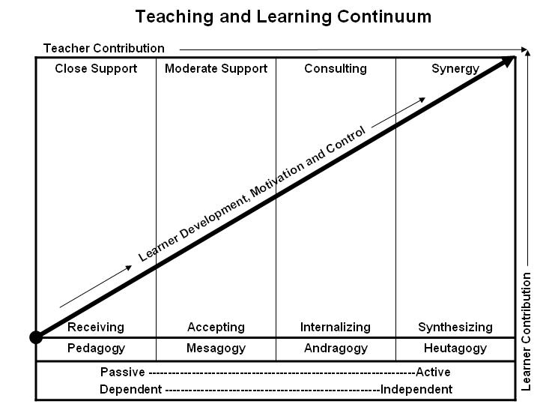
Learner’s Knowledge, Skills and Abilities
Indicator | Key Terms | Description
1 | Limited Knowledge and Proficiency | - Recognize basic information about the subject including terms and nomenclature.  - Students must demonstrate ability to recall information such as facts, terminology or rules related to information previously taught.  - Performs simple parts of the competency. Student requires close supervision when performing the competency.
2 | Moderate Knowledge and Proficiency | - Distinguish relationships between general principles and facts. Adopts prescribed methodologies and concepts.  - Students must demonstrate understanding of multiple facts and principles and their relationships, and differentiate between elements of information. Students state ideal sequence for performing task.  - Performs most parts of the competency with instructor assistance as appropriate.
3 | Advanced Knowledge and Proficiency | - Examines conditions, findings, or other relevant data to select an appropriate response.  - The ability to determine why and when a particular response is appropriate and predict anticipated outcomes.  - Students demonstrate their ability to seek additional information and incorporate new findings into the conclusion and justify their answers.  - Performs all parts of the competency without instructor assistance.
4 | Superior Knowledge and Proficiency | - Assessing conditions, findings, data, and relevant theory to formulate appropriate responses and develop procedures for situation resolution. Involves higher levels of cognitive reasoning.  - Requires students to formulate connections between relevant ideas and observations.  - Students apply judgments to the value of alternatives and select the most appropriate response.  - Can instruct others how to do the competency.  - Performs competency quickly and accurately.
A | Affective Objective | - Describes learning objectives that emphasize a feeling tone, an emotion, or a degree of acceptance or rejection.  - Objectives vary from simple attention to selected phenomena to complex but internally consistent qualities of character and conscience.  - Expressed as interests, attitudes, appreciations, values, and emotional sets or biases.

